Personal Finance Analysis Report

1. Introduction
This project focuses on analysing personal financial data to understand income patterns, spending behaviour, and savings trends. Using SQL for Exploratory Data Analysis (EDA) and Power BI for visualization, the objective is to derive actionable insights that improve financial decision-making.

Problem
Individuals often lack visibility into their spending patterns, leading to:
- Poor financial planning
- Low savings
- Overspending in certain categories

2. Objectives
- Analyse total income and expenses
- Identify major spending categories
- Track monthly financial trends
- Evaluate savings performance
- Measure correlation between income and expenses
- Build an interactive dashboard for insights

3. Dataset Description
The dataset contains financial records with key attributes such as:
- Date / Month
- Type (Income / Expense/ Saving)
- Component (Category like Rent, Food, Salary, etc.)
- Value (Amount)

4. SQL-Based EDA
Key Analysis Performed
4.1 Total Income vs Expenses
- Calculated total income and total expenses
- Identified overall financial balance
4.2 Category-wise Expense Analysis
- Grouped expenses by components
- Found highest spending categories using:
4.3 Percentage Contribution (Expense Share)
- Used window functions to calculate contribution:
4.4 Monthly Trend Analysis
- Aggregated income & expenses month-wise
- Identified patterns and fluctuations
4.5 Savings Calculation
- Savings = Income – Expenses
- Evaluated monthly savings trend

6. Dashboard Insights

Dashboard Overview

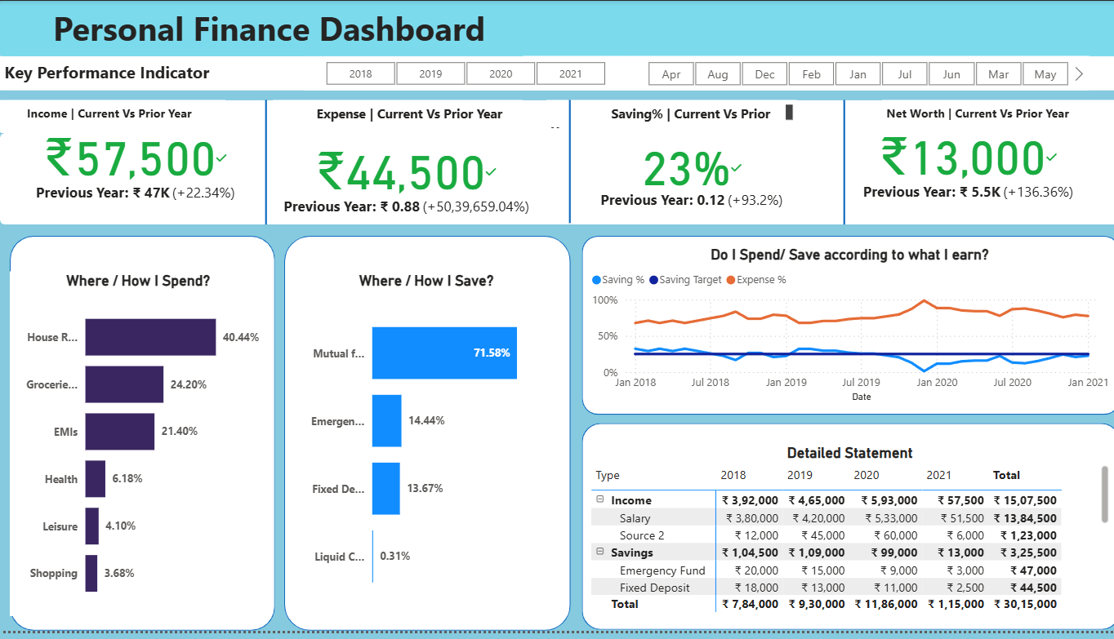

This dashboard presents the complete financial dashboard, highlighting key KPIs such as Total Income, Total Expenses, and Savings. It provides a quick summary of overall financial performance. Show the relationship between Expense and Saving , compare the saving with the target saving.

Saving vs Expense Trend
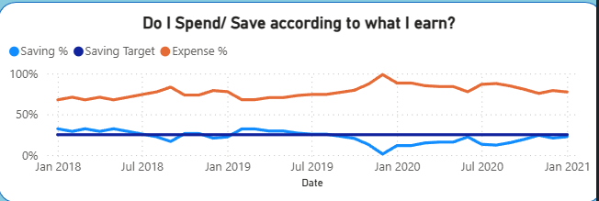
This visualization shows the monthly comparison between saving and expenses. It helps identify trends, seasonal variations, and periods of financial imbalance. In 2020 saving is below the target level .

Expense Distribution
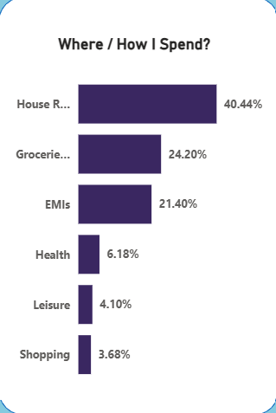
This chart illustrates the percentage contribution of each expense category (e.g., Rent, Food, Travel), helping to identify major spending areas. House Rent, Groceries and EMI Contribute 84% of total expense.

Savings Analysis
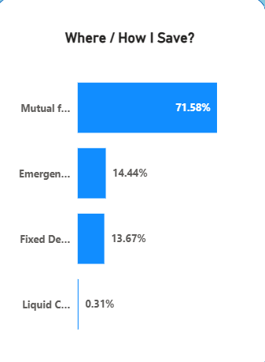
This chart illustrates the percentage contribution of each saving category (e.g., Mutual Fund, Emergency Fund, Fixed Deposit and Liquid Cash), helping to identify major Saving areas.

Solution
- Use data-driven insights to track income & expenses
- Identify high-spending categories and reduce unnecessary costs
- Monitor savings regularly
- Utilize dashboards for better financial control

Conclusion
The dashboard effectively transforms financial data into actionable insights, helping users improve budgeting, control expenses, and increase savings.

